**STOCK MARKET ANALYSIS**

### 

### **Closing Prices Trends**

* **Objective**: To identify price movements over time for four companies: Apple (AAPL), Google (GOOG), Microsoft (MSFT), and Netflix (NFLX).
* **Analysis:**
  + The graph shows weekly stock prices over a period from February to April 2023.
  + NFLX (Netflix): Experienced sharp fluctuations early on, with peaks around mid-February and steadying out toward the end of April.
  + MSFT (Microsoft): Showed a gradual upward trend with occasional drops but with overall growth.
  + GOOG (Google): Had a volatile trend, showing both ups and downs but with a lower overall growth trajectory compared to NFLX and MSFT.
  + AAPL (Apple): Showed the least movement, with prices staying relatively steady throughout the period
* **Conclusion**:
  + **Netflix (NFLX)** experienced significant fluctuations, indicating higher volatility.
  + **Microsoft (MSFT)** showed consistent upward growth, suggesting strong market performance and investor confidence.
  + **Google (GOOG)** had more unpredictable price changes, making it a moderate-risk option.
  + **Apple (AAPL)** displayed the most stability, making it a safer, low-volatility stock option during this period.

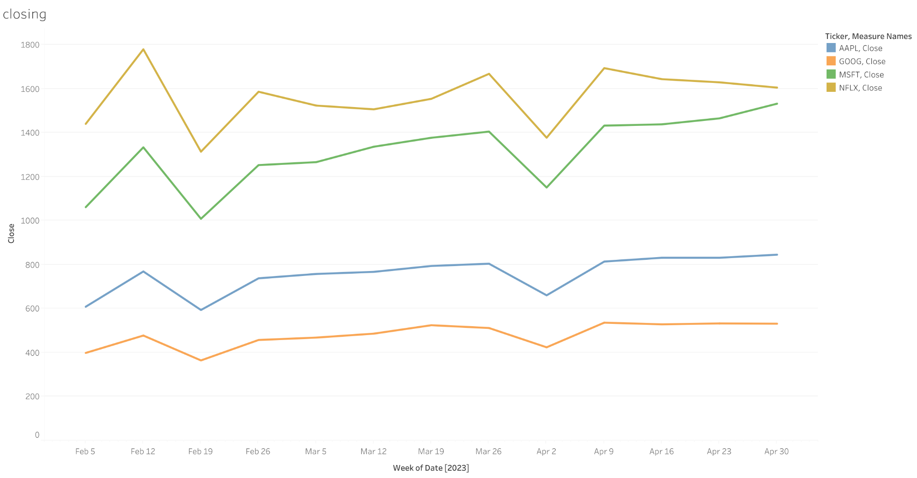

**Moving Average Analysis**

* **Objective:** To analyze the moving average of closing prices to smooth out fluctuations and spot long-term trends.
* **Analysis:**
  + The moving average chart shows the collective behavior of the four stocks over a 32-day period.
  + **Apple (AAPL)** and **Microsoft (MSFT)** contribute the most to the overall market movement.
  + The peaks in the moving average correspond to days when **AAPL** and **MSFT** experience higher fluctuations.
  + **NFLX (Netflix)**: Maintains lower price stability, as indicated by smaller peaks and troughs in the moving averages compared to the other stocks.
  + **GOOG (Google)** also follows a similar trend but with slightly higher volatility, as shown by fluctuations in the moving average plot.

**Conclusion**:

* The moving averages reveal that **AAPL** and **MSFT** contributed significantly to the overall market stability, while **NFLX** added more volatility.
* Peaks in the moving average reflect increased market activity or significant events affecting stock performance, with **AAPL** and **MSFT** generally leading these movements.
* **NFLX**'s steadier, smaller peaks suggest that its volatility was not as persistent as **AAPL** or **MSFT** but still contributes to notable fluctuations.

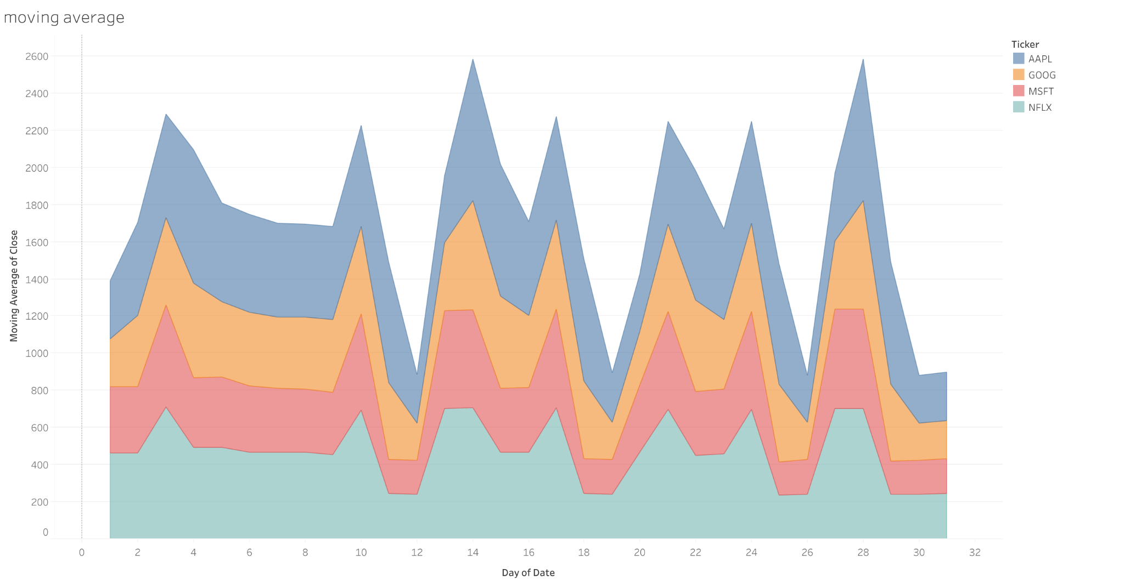

### **Support and Resistance**

* **Objective:** To identify key support and resistance levels for each company's stock.
* **Analysis:**
  + Each company's stock data is shown on its own panel with the high and low values plotted.
  + **Apple (AAPL)**: The support level appears to be around 150, while resistance was found just below 200. There's a gradual upward trend, suggesting potential bullish momentum.
  + **Google (GOOG)**: Shows a fairly narrow band between 90 and 110, indicating consistent support and resistance levels.
  + **Microsoft (MSFT)**: Displays strong upward momentum with a resistance level around 310 and support around 280.
  + **Netflix (NFLX)**: The stock experienced a drop followed by a recovery, with a support level near 250 and resistance at 350.

**Conclusion**:

* **AAPL** and **MSFT** show bullish trends with increasing support levels, indicating potential for continued growth.
* **GOOG** maintained a tight support-resistance range, suggesting stability with limited breakout potential in the short term.
* **NFLX** faced more unpredictable movements but displayed a potential recovery after a mid-period drop, making it riskier but with potential upside.

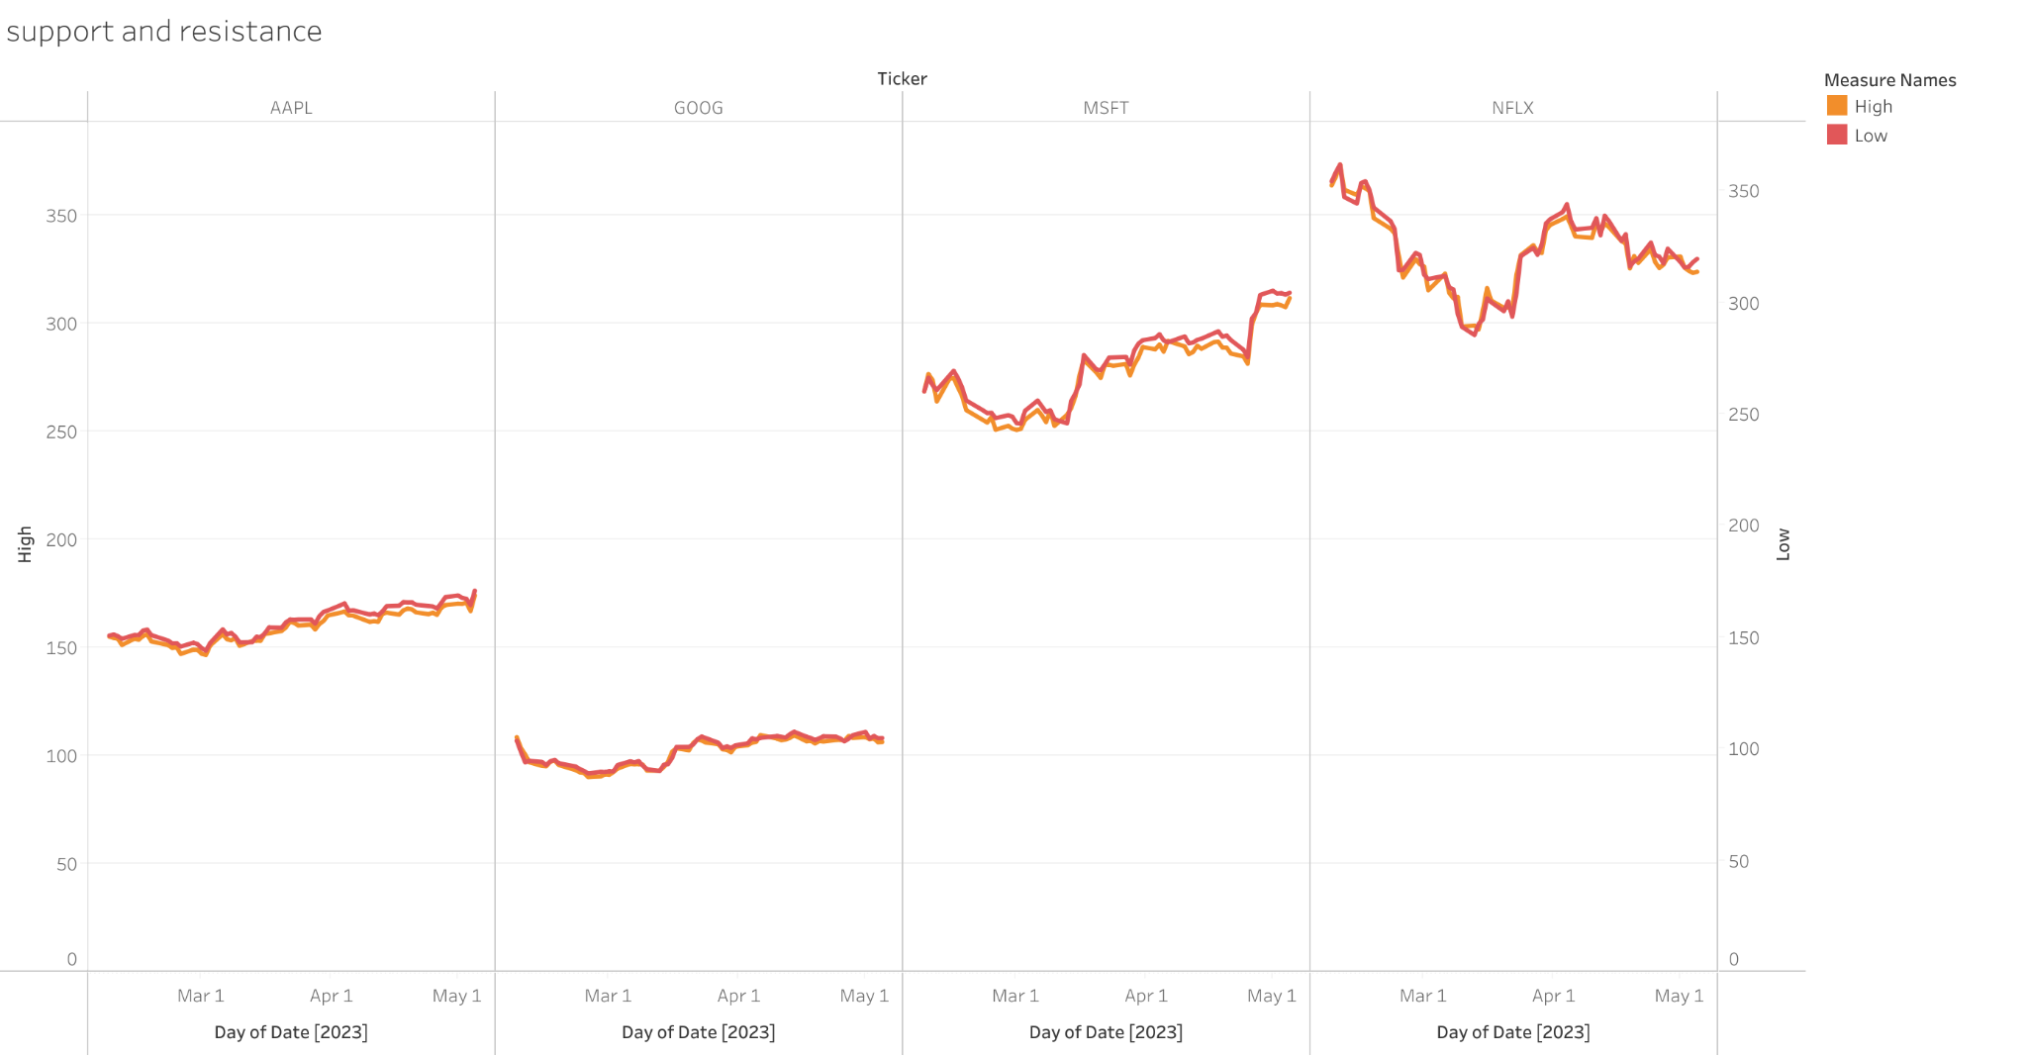

### 

### 

### 

### **Daily Price Change Analysis**

**Objective:** To examine daily stock price percentage changes to assess market volatility and the market's reaction to various events from February to May 2023.

**Analysis:**

* **High Volatility Periods:**
  + Early February experienced a significant **+10% spike**, followed by a sharp **-12% drop** around February 6-8. This suggests strong market reactions to external events or announcements, likely affecting stocks such as NFLX and MSFT.
  + Mid-March also saw large fluctuations, with multiple days of **+6% to +10%** increases, followed by sudden drops. This is indicative of investor sentiment rapidly shifting due to market news or earnings reports.
* **Bearish Trends:**
  + Late February to early March shows consistent negative price movements with drops reaching **-4% to -6%**. This period reflects bearish market conditions, possibly triggered by economic uncertainty or adverse sector-specific news.
  + Similarly, late April displayed several days of declining prices, with certain stocks experiencing **-3% to -5%** decreases. This trend suggests a weakening market sentiment during that time.
* **Stability Periods:**
  + Some periods, especially in early April, show relatively smaller changes between **+2% to -2%**, indicating market stability and lower volatility. Stocks such as AAPL and GOOG are likely contributing to this steadier behavior.
* **Recovery Spikes:**
  + March and mid-April saw notable price recovery periods with **+6% to +12%** price increases after prior drops, showing potential bounce-back momentum after bearish phases.

**Conclusion:**

* **Netflix (NFLX)** experienced sharp fluctuations, indicating the highest volatility among the four stocks.
* **Microsoft (MSFT)** displayed significant gains and drops, showing both growth potential and short-term risks.
* **Google (GOOG)** had moderate price swings, making it a mid-level risk investment.
* **Apple (AAPL)** remained the most stable, with minimal fluctuations, reflecting low volatility and reliability.

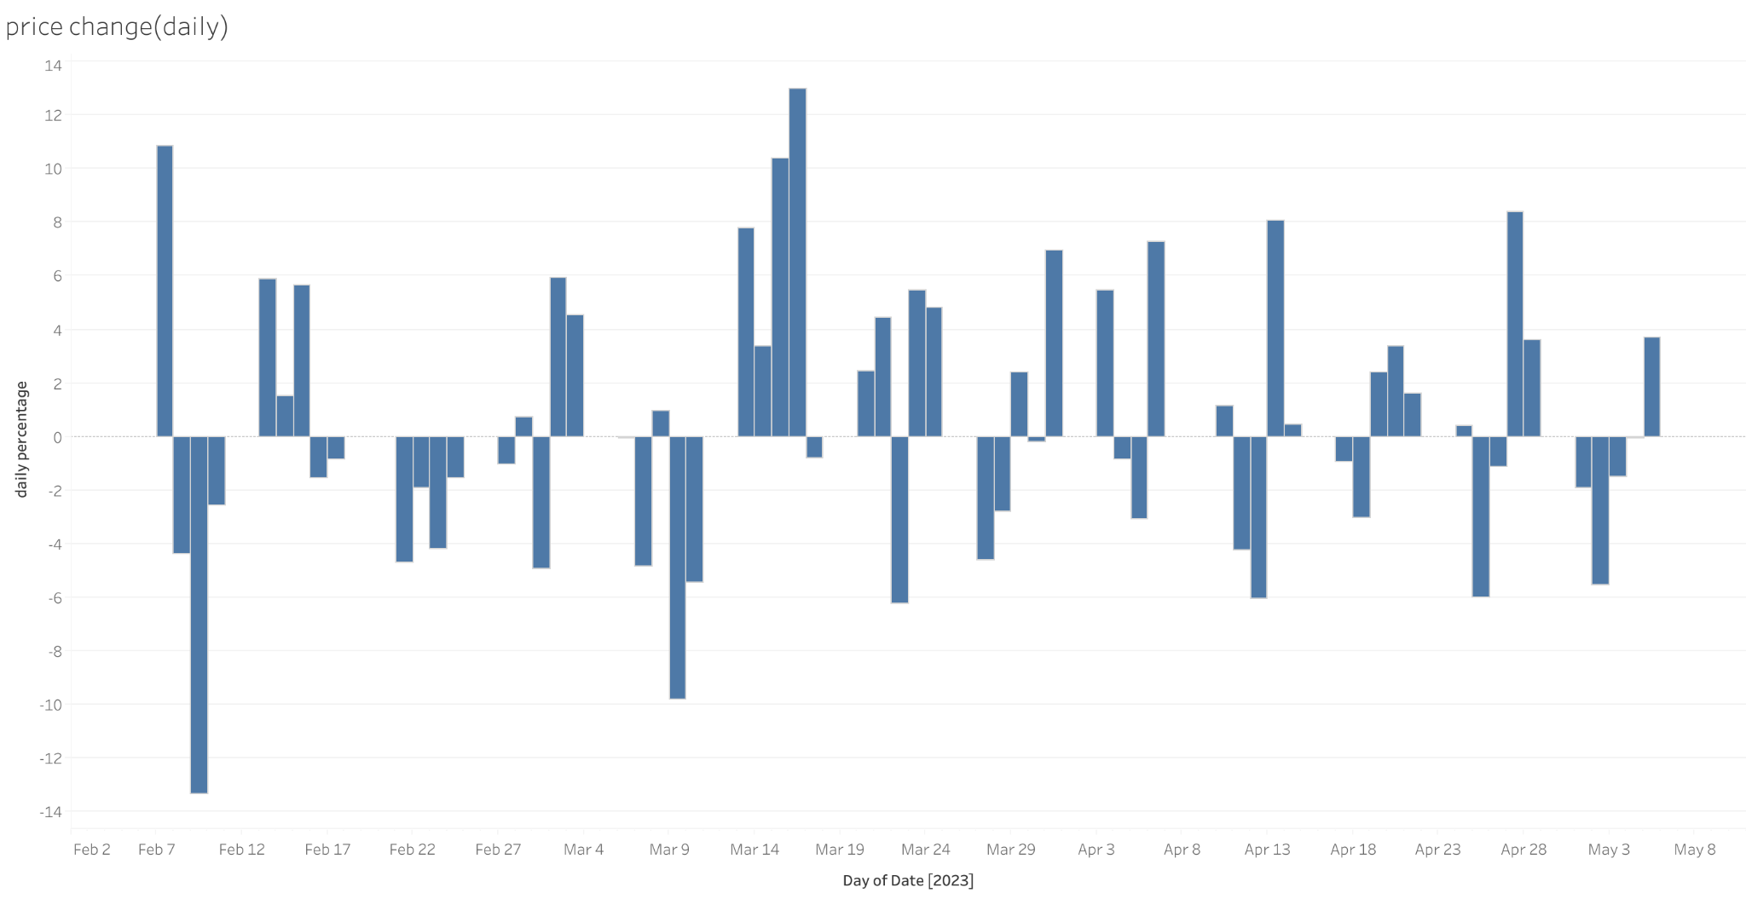

**Volatility Analysis**

1. **Objective**:  
   To assess and compare the volatility patterns of four companies — Apple (AAPL), Google (GOOG), Microsoft (MSFT), and Netflix (NFLX) — between February and May 2023, and identify high-risk and low-risk periods for each stock.
2. **Analysis**:
   * All four companies experienced fluctuations in volatility over time, with certain peaks and troughs aligning between the stocks.
   * **Netflix (NFLX)**: The volatility for NFLX shows sharp spikes, particularly in mid-March and late April, indicating periods of rapid price movement, suggesting high risk during these periods.
   * **Google (GOOG)**: Displays moderate volatility, with noticeable peaks in February and April, but remains relatively stable compared to NFLX.
   * **Microsoft (MSFT)**: The volatility for MSFT is consistent, showing periodic spikes (in March and April), with overall medium volatility compared to the other stocks.
   * **Apple (AAPL)**: AAPL remains the most stable with the least volatility, reflecting its nature as a low-risk stock. There are minor peaks in volatility, but they are lower compared to the other companies.

**Conclusion**:

* **Netflix (NFLX)** exhibited the highest volatility among the four companies, with significant price fluctuations especially in mid-March and late April. These sharp spikes suggest that NFLX was prone to rapid and unpredictable price movements during this period, making it a high-risk stock for short-term investors. This level of volatility is often attractive to traders seeking opportunities for quick gains but poses risks for long-term investors who may prefer more stability.
* **Microsoft (MSFT)** showed moderate volatility, with consistent upward trends interspersed with occasional spikes in March and April. These spikes indicate periods of increased uncertainty, but overall, MSFT's volatility suggests a balanced risk-reward profile. Investors might find this stock attractive for its growth potential, coupled with a reasonable amount of risk.
* **Google (GOOG)** also displayed moderate volatility, with price changes that were generally more controlled than NFLX but still prone to some unpredictability. The spikes in February and April show moments of higher market activity or external factors affecting its stock price. For investors, GOOG may represent a moderate-risk option, combining periods of stability with occasional opportunities for growth.
* **Apple (AAPL)** was the least volatile of the four companies, displaying the smallest fluctuations throughout the period. This stability suggests that AAPL was the safest option for risk-averse investors during this time, making it a reliable choice for those looking for steady returns without the high risk of sudden price swings. Its consistent behavior reflects strong market confidence and a more predictable investment opportunity.

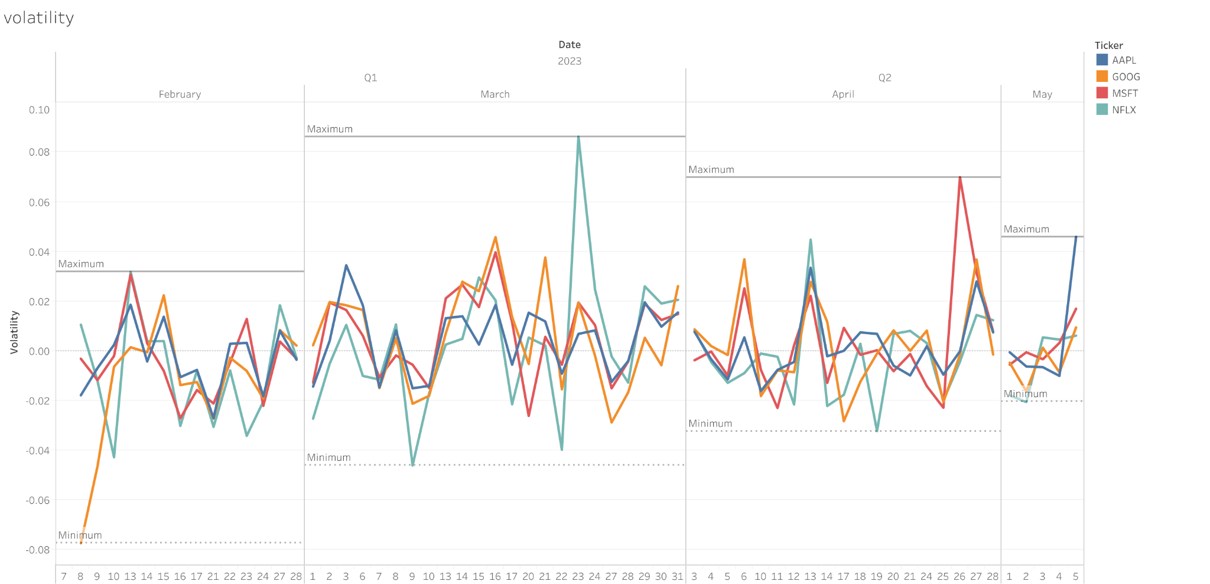

## **Analysis of Stock Prices and Volumes:**

**Objective:** To analyze the price movements and trading volumes of four major tech stocks (AAPL, GOOG, MSFT, and NFLX) from early February to late May 2023.

**Key Observations:**

**Price Movements:**

* **AAPL:** Experienced a steady upward trend, with a significant price increase in early March.
* **GOOG:** Showed a similar upward trend, with a slight dip in mid-March.
* **MSFT:** Had a more volatile price pattern, with a sharp decline in early March followed by a gradual recovery.
* **NFLX:** Experienced a significant price drop in early March, followed by a slow recovery.

**Trading Volumes:**

* **AAPL:** Saw increased trading volume during periods of price volatility, especially in early March.
* **GOOG:** Also experienced higher trading volume during price fluctuations, but to a lesser extent than AAPL.
* **MSFT:** Had the highest overall trading volume, indicating greater investor interest.
* **NFLX:** Experienced a surge in trading volume during the price drop in early March, but volumes declined as the stock recovered.

**Conclusion:**

* **AAPL, GOOG, and MSFT:** Demonstrated generally positive price performance and increased trading activity during periods of volatility.
* **NFLX:** Experienced a significant price decline but showed signs of recovery towards the end of the period.
* Further analysis, including correlation analysis and fundamental/technical analysis, could provide deeper insights into the drivers of these stocks' price movements and trading volumes.

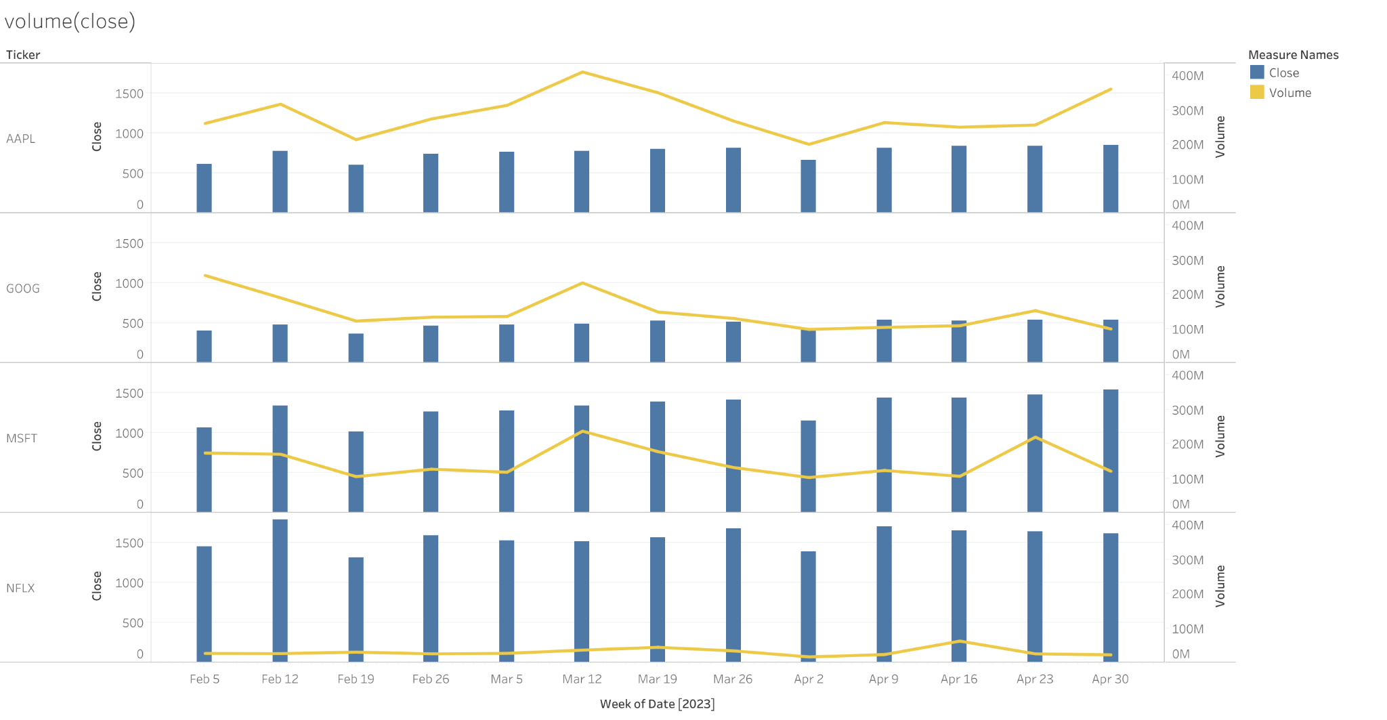

**Correlation Analysis**

**Apple (AAPL)**

**Volatility**: Apple's volatility remains moderate throughout the observed period, indicating a stable stock. Unlike more volatile stocks such as Netflix, Apple’s controlled fluctuations suggest that investors are less likely to see drastic price movements over short time frames.

**Volume vs. Close Price:** There is a clear relationship between volume and close price for Apple. As trading volumes rise, the closing price tends to increase as well, showing that higher market interest often drives prices upwards. This trend points to a relatively efficient market, where price changes are driven by natural supply and demand dynamics.

**Support and Resistance** :The support and resistance levels for Apple show a consistent upward trend, indicating that the stock is in a bullish phase. Resistance levels increase progressively, suggesting a steady market sentiment where buyers continue to drive the price higher.

**Daily Price Change**: Apple’s daily price changes are small and consistent, correlating with its moderate volatility. The controlled nature of these changes makes Apple a more stable investment, suitable for risk-averse investors who seek steady returns without sharp fluctuations.

**Google (GOOG)**

**Volatility**: Google exhibits slightly higher volatility compared to Apple, but it is still moderate compared to Netflix. This indicates that Google’s stock experiences more significant price swings than Apple, though it remains more stable than highly volatile stocks.

**Volume vs. Close Price**: The relationship between volume and close price is less predictable for Google. There are instances where the close price decreases while trading volume remains high, suggesting that market sentiment or external factors (like regulatory news or earnings reports) may be influencing the price independently of volume.

**Support and Resistance:** Google’s support and resistance levels are flatter compared to Apple, showing less overall movement in either direction. This implies that the market sentiment is more neutral, with fewer upward trends or significant breakthroughs beyond resistance levels.

**Daily Price Change:** Google's daily price changes reflect its moderate volatility. There are occasional sharp drops, particularly in late March, which may coincide with market events. The presence of these fluctuations aligns with Google’s overall moderate volatility and weaker correlation between volume and price.

**Microsoft (MSFT)**

**Volatility**: Microsoft’s volatility is similar to Apple’s, remaining relatively moderate throughout the period. This consistency signals that Microsoft shares are fairly stable and do not undergo large price swings, contributing to its reputation as a reliable, blue-chip stock.

**Volume vs. Close Price**: Like Apple, Microsoft shows a strong relationship between volume and close price. Increased trading volumes generally correlate with upward movements in the close price, suggesting that market interest directly impacts price performance.

**Support and Resistance:** Microsoft’s support and resistance levels show a clear upward trajectory, similar to Apple’s. The resistance levels are progressively higher, indicating that market sentiment is bullish, and investors are willing to push the price higher over time.

**Daily Price Change:** Microsoft experiences small but steady daily price changes. While there are occasional increases in daily percentage change, these are generally mild, which corresponds with its moderate volatility and consistent upward trend in support/resistance. Microsoft’s stability makes it attractive to conservative investors who prefer growth with limited risk.

**Netflix (NFLX)**

**Volatility**: Netflix stands out for its high volatility, particularly in mid-March, when the stock experienced sharp spikes. This suggests that Netflix is more susceptible to dramatic price movements, likely driven by news, earnings reports, or shifts in market sentiment.

**Volume vs. Close Price**: The correlation between volume and close price is weaker for Netflix compared to the other companies. Despite increases in volume, the closing price fluctuates unpredictably, indicating that other factors (such as market speculation or reactions to external events) play a larger role in price movements.

**Support and Resistance**: Netflix’s support and resistance levels are highly erratic, reflecting its volatile nature. Resistance levels shift rapidly, particularly in March, where price movements are more abrupt. This suggests that investors face greater uncertainty with Netflix, as support and resistance levels do not provide strong guidance for future price movements.

**Daily Price Change**: The daily price changes for Netflix are the most extreme of the four companies analyzed. There are large swings both upward and downward, corresponding to its high volatility. This unpredictability makes Netflix a high-risk investment, as investors may experience significant gains or losses within short periods.

**Conclusion**

**Apple and Microsoft**: Both companies exhibit similar patterns across the various graphs, with moderate volatility, a clear relationship between volume and close price, and a steady increase in support and resistance levels. Their small daily price changes and stable patterns suggest that these companies are reliable investments for those seeking steady growth with limited risk. The market sentiment for both remains bullish, as evidenced by their upward resistance levels.

**Google:** Google shows more fluctuation than Apple and Microsoft but remains relatively stable compared to Netflix. Its weaker correlation between volume and close price and its flatter support and resistance levels suggest that external factors may be playing a larger role in Google’s price movements. Google’s moderate volatility and occasional price drops make it a medium-risk investment.

**Netflix:** Netflix is the most volatile stock, with erratic price movements, fluctuating support and resistance levels, and large daily price swings. The weak correlation between volume and close price further highlights the unpredictability of Netflix. As a high-risk stock, it may offer significant gains, but it also comes with the possibility of substantial losses due to its volatility and unpredictable market behavior. Investors in Netflix should be prepared for a more speculative and riskier investment environment.

Overall, investors can choose their strategy based on risk tolerance. Apple and Microsoft are safer, long-term growth options, Google offers moderate risk with occasional fluctuations, and Netflix is more suited for speculative traders seeking short-term, higher-risk opportunities. By understanding the different characteristics of these stocks, investors can make more informed decisions aligned with their financial goals and risk appetites.